NATIONAL UNIVERSITY OF MODERN LANGUAGES
IICT LAB ASSIGNMENT # 01

SUBMITTED BY:
ZULQARNAIN HASSAN

SUBMITTED TO:
SIR MUBASHIR
System ID: NUML-S22-15676
Faculty: Engineering and computer science
Department: Software engineering
Section: BSSE-1-A-afternoon

- State the difference between HDD, SSD and NVMe.

HDD
- Hard disk contains one or many platters (disks) coated with magnetic material on both sides. The platters are attached to a spindle holding them in parallel with an equal gap.
- Bits are stored on the magnetic surface in spots along concentric circles called tracks.
- Hard disks contain thousands of tracks. Tracks are divided into sections called sectors.
- Each platter has two read/write heads for writing dada to and reading data from both surfaces of the platter.
- Hard disks are manufactured in a very clean environment. They must be kept dust fee.

SSD
- A solid-state drive is a solid-state storage device that uses integrated circuit assemblies to store data persistently, typically using flash memory and functioning as secondary storage in the hierarchy of computer storage.
- A solid-state drive (SSD) is a new generation of storage devices used in computers.
- SSDs used flash-based memory, which is much faster than a traditional mechanical hard disk.

NVMe
- NVMe (nonvolatile memory express)is new storage access and transport protocol for flash and next-generation solid-state drive.
- It is commonly used for solid-state storage, main memory, cache memory ,or backup memory.
- It provides an alternative to the small computer system interface (SCSI) standard and the advanced technology attachment(ATA)standard for connecting and transmitting data between a host system and a target storage device.

Q.NO#02.State difference between a CPU, GPU and TPU?
CENTRAL PROCESSING UNIT:-
A central processing unit is also called a central processor, main processor or just processor, is an electronic circuit that executes instructions comprising a computer program. The CPU preform basic arithmetic, logic, controlling, and input/output operations by the instruction in the program.
GRAPHICS PROCESSING UNIT:-
A GPU is a specialized processor originally designed to accelerate graphics rendering. GPUs can process many pieces of data simultaneously, making them useful for machine learning, video editing, and gaming application.
TENSOR PROCESSING UNIT:-
Tensor Processing Units are Google’s custom-developed application-specific integrated circuits used to accelerate machine learning workloads. TPUs are designed from the ground up with the benefits of Google’s deep experience and leadership in machine learning.
TPU is a hard plastic material. The cell phone covers produced using TPU cover most parts of the phones. This will give a complete protection to a device.

Q.NO#03.Does the Mac of two router can be same?
No two devices on a local network should ever have the same MAC address. If that does happen, both devices will have communications problems because the local network will get confused about which device should receive the packet.

Q.NO#04.Does the local IP (private IP) of two different LANs can be same?
Private IP addresses of two different networks can be same. It is the public IP that is needed to be unique which we assign to router. While communicating to external network only router's address is used.
Conclusion:
In this report we learned about the difference between HDD, SSD and NVME. HDD store information on hard disk and SSD is a solid state storage device that uses integrated circuit assemblies as memory to store data persistently, while NVME host controller interference specification is open, logical device interface specification of accessing a computer non-volatile storage media usually attached via PCL.
Also we learned about CPU, GPU, TPU and MAC Addresses of routers.
- CPU: CPU manage all the function of a computer.
- GPU: GPU enhanced the graphical performance of the computer.
- TPU: TPU custom build ASIC to accelerate Tensor Flow project.

Q.NO#05: Take the screenshot of GUI of five different applications and attached with the reports?
1: GUI OF MS WORD

2: GUI OF BROWSER FIREFOX

3: GUI OF MS EXEL


4:GUI OF DEV C₊₊ 5: GUI OF ADOBE PHOTOSHOP
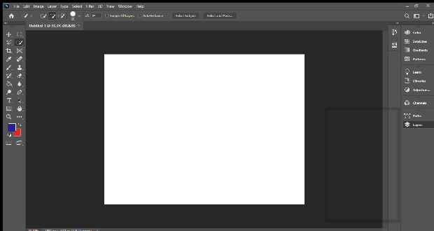

Q.NO#06: What is the difference between the file-extension?
- Doc and docx:
The main difference between the two file formats is that in DOC, your document is saved in a binary file that includes all the related formatting and other relevant data while a DOCX files is actually a zip file with all the XML files associated with the document.
- DOC is a binary format while DOCX is based on XML.
- DOCX is open standard while DOC is proprietary.
- DOCX allow you to work with new features but DOC doesn’t allow.
- Jpg and jpeg:
There are actually no difference between the JPG and JPEG formats. The only difference between then is that the number of character used. JPG is exist in early version of windows because they required a three-letter extension for the file names.
- JPG stand for Joint Photographic group.
- JPG stand for Joint Photographic expert group.
- Both images apply lousy compression which result in a loss of quality.
Conclusion:
- Learn about difference between DOC and DOCX.
- Screenshot of GUI.
- Difference between JPG and JPEG.
- Uses of JPG in early version of window.
- JPG stand for Joint Photographic group.
- JPG stand for Joint Photographic expert group.
- Both images apply lousy compression which result in a loss of quality.
THE END

